Name: BOYA DRAVEEN KUMAR

Trainer Name:HARSHEE PITRODA

Batch Number: **09(G-15)**

Course Name:**Mechain learning with python**

Date:**02-Jun-2022**

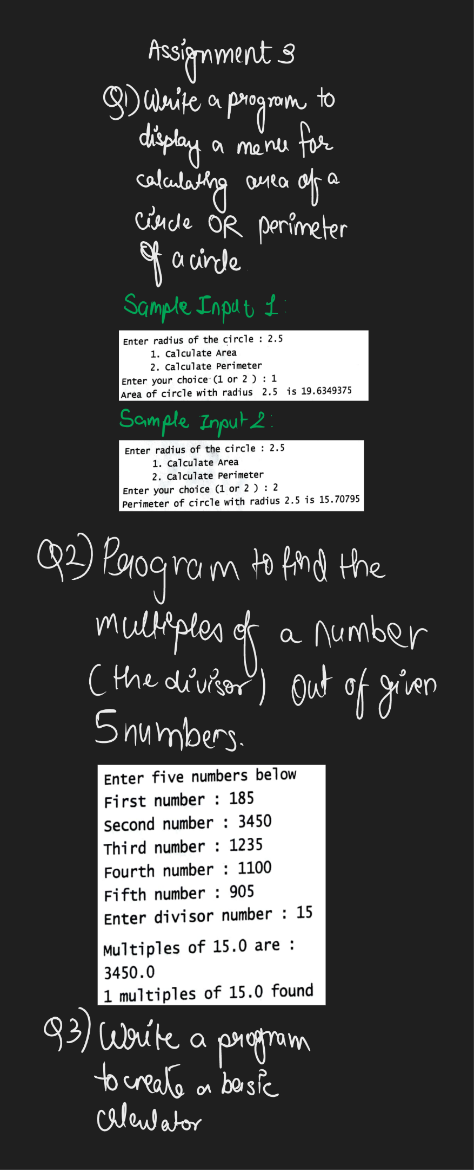

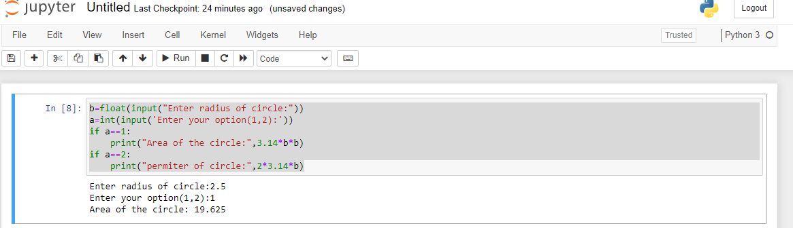

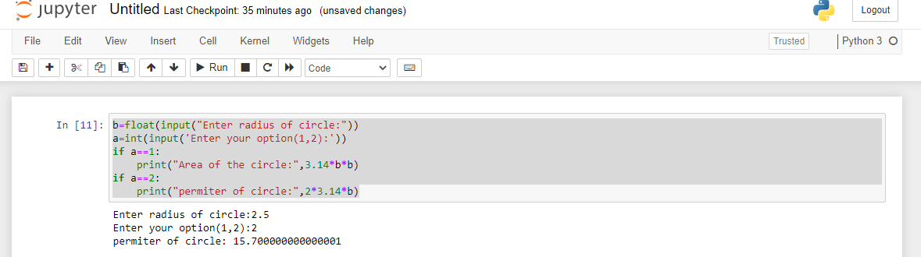

b=float(input("Enter radius of circle:"))

a=int(input('Enter your option(1,2):'))

if a==1: #1st Question

print("Area of the circle:",3.14*b*b)

if a==2:

print("permiter of circle:",2*3.14*b)

Sample input:

Enter radius of circle:2.5

Enter your option(1,2):1

Sample output:

Area of the circle: 19.625

Sample input:

Enter radius of circle:2.5

Enter your option(1,2):2

Sample output:

permiter of circle: 15.700000000000001

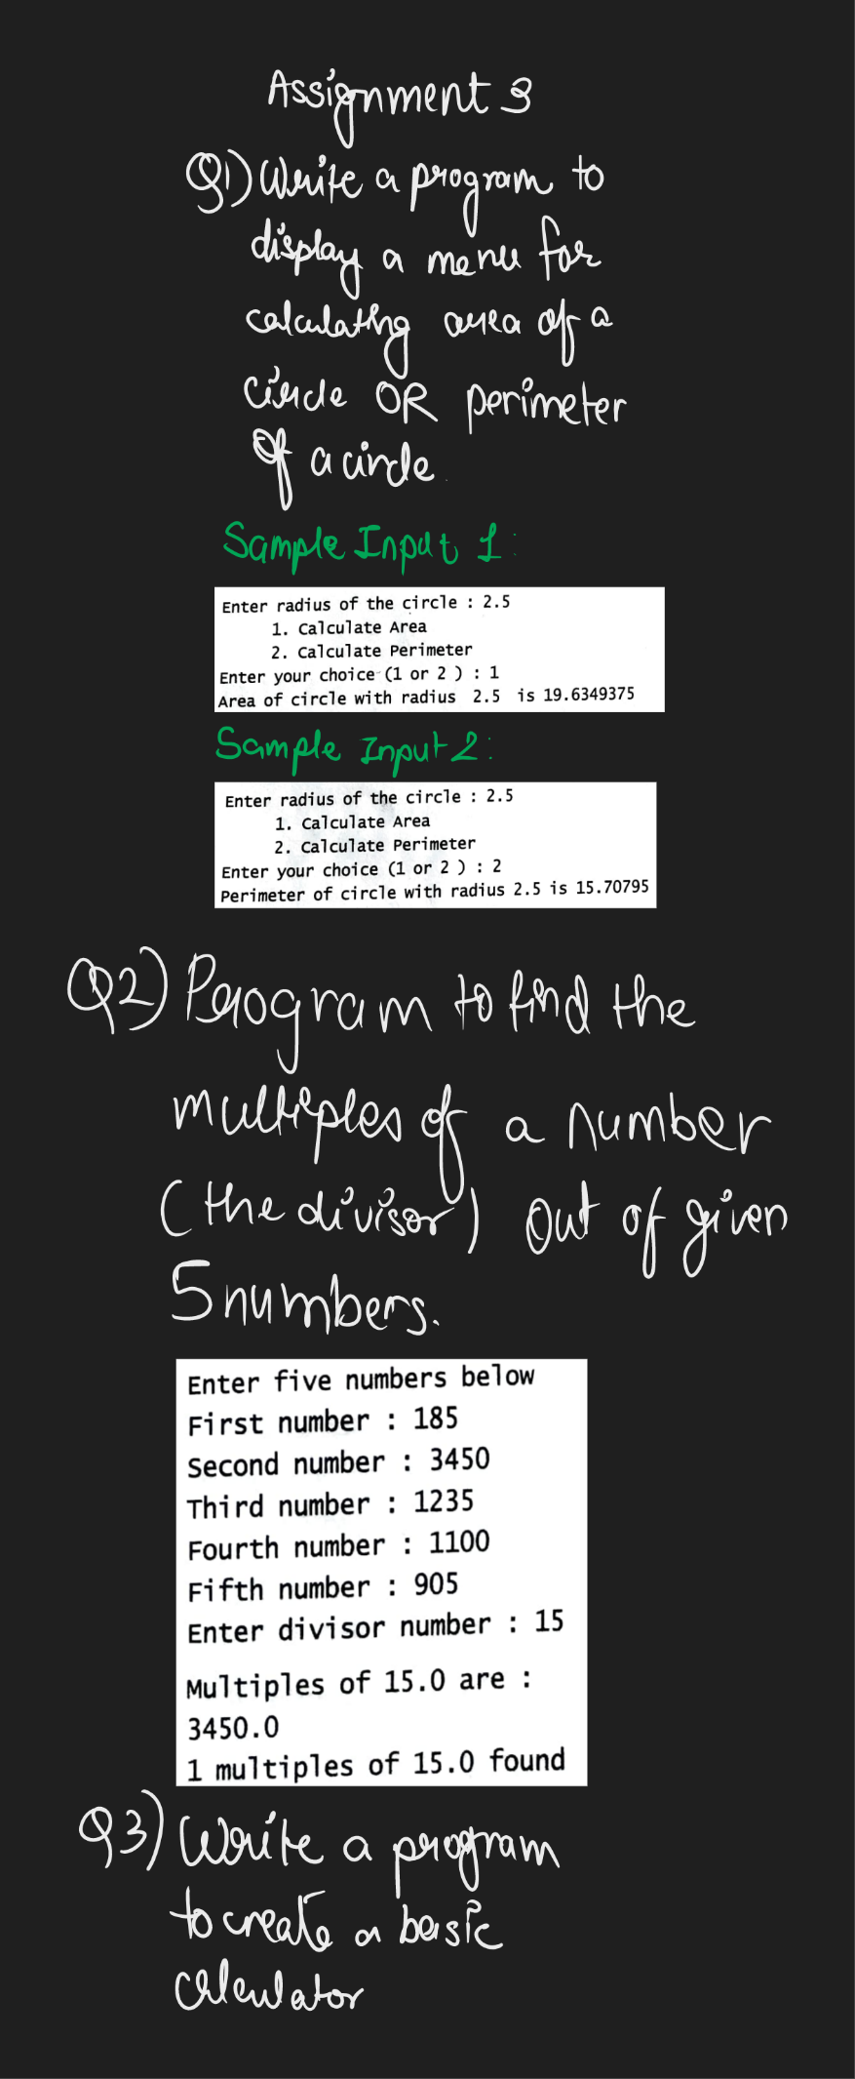

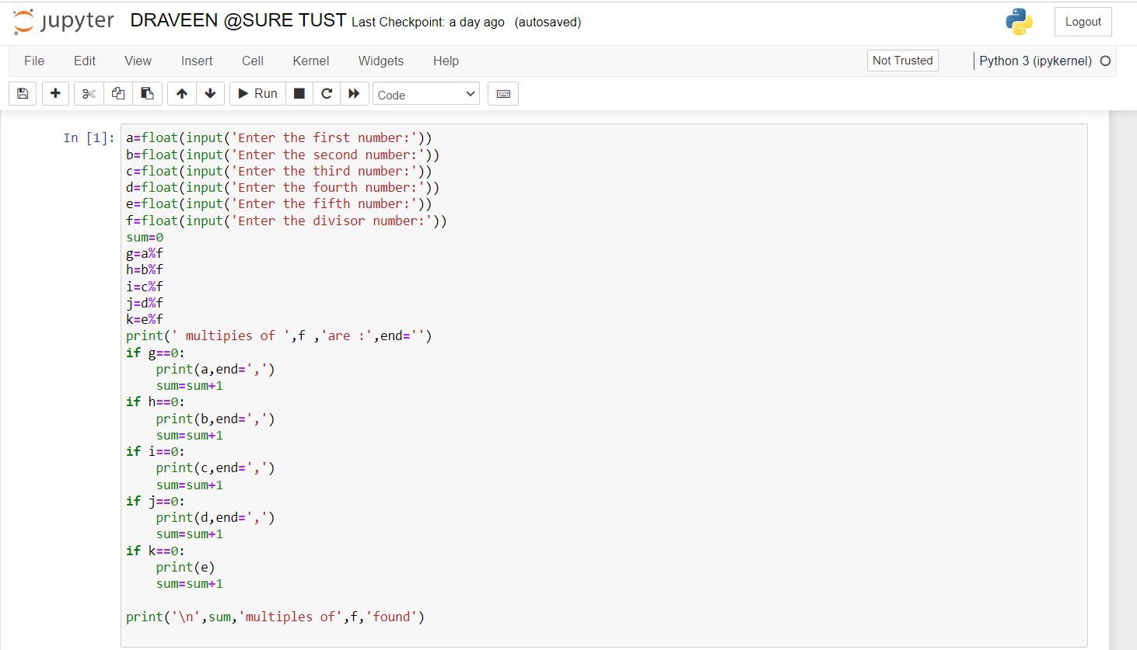

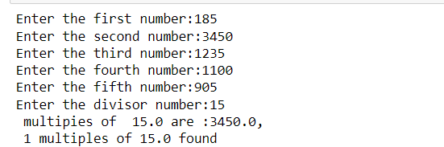

a=float(input('Enter the first number:'))

b=float(input('Enter the second number:'))

c=float(input('Enter the third number:'))

d=float(input('Enter the fourth number:'))

e=float(input('Enter the fifth number:'))

f=float(input('Enter the divisor number:')) #2nd Question

sum=0

g=a%f

h=b%f

i=c%f

j=d%f

k=e%f

print(' multipies of ',f ,'are :',end='')

if g==0:

print(a,end=',')

sum=sum+1

if h==0:

print(b,end=',')

sum=sum+1

if i==0:

print(c,end=',')

sum=sum+1

if j==0:

print(d,end=',')

sum=sum+1

if k==0:

print(e)

sum=sum+1

print('\n',sum,'multiples of',f,'found')

Sample input:

Enter the first number:185

Enter the second number:3450

Enter the third number:1235

Enter the fourth number:1100

Enter the fifth number:905

Enter the divisor number:15

multipies of 15.0 are :3450.0,

Sample output:  
1 multiples of 15.0 found



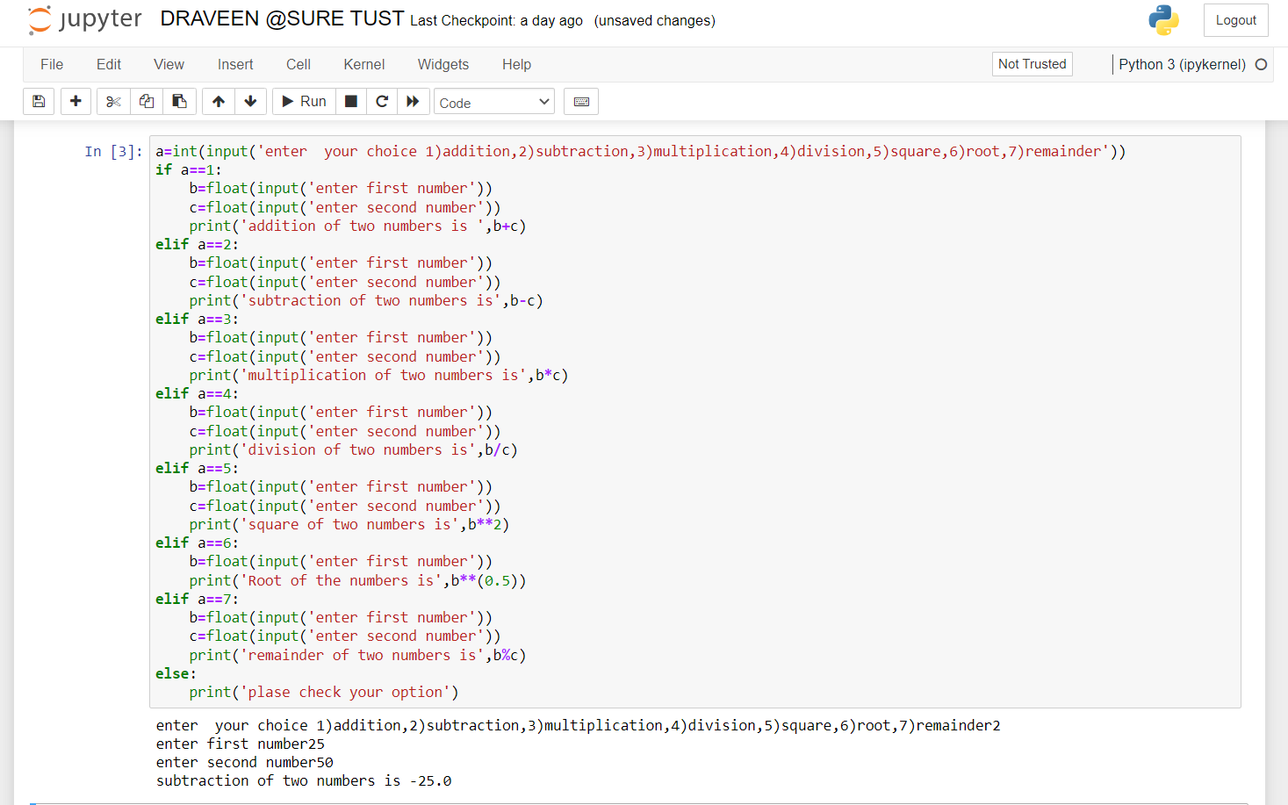

a=int(input('enter your choice 1)addition,2)subtraction,3)multiplication,4)division,5)square,6)root,7)remainder'))

if a==1:

b=float(input('enter first number'))

c=float(input('enter second number'))

print('addition of two numbers is ',b+c)

elif a==2:

b=float(input('enter first number')) #3rd Question

c=float(input('enter second number'))

print('subtraction of two numbers is',b-c)

elif a==3:

b=float(input('enter first number'))

c=float(input('enter second number'))

print('multiplication of two numbers is',b*c)

elif a==4:

b=float(input('enter first number'))

c=float(input('enter second number'))

print('division of two numbers is',b/c)

elif a==5:

b=float(input('enter first number'))

c=float(input('enter second number'))

print('square of two numbers is',b**2)

elif a==6:

b=float(input('enter first number'))

print('Root of the numbers is',b**(0.5))

elif a==7:

b=float(input('enter first number'))

c=float(input('enter second number'))

print('remainder of two numbers is',b%c)

else:

print('plase check your option')

Sample input:

enter your choice 1)addition,2)subtraction,3)multiplication,4)division,5)square,6)root,7)remainder2

enter first number25

enter second number50

Sample output:

subtraction of two numbers is -25.0